**Office 2019**

**Install and Activate**

**How to customize MS office applications and activate the license** for individual apps?

Here we are not installing the MS office as a complete package instead of that we are customizing (Installing as a single application).

Let’s start…

Right click on the office deployment tool and click on open it will extract the below three .xml files.

In those 3 files open **configuration-Office2019Enterprise.xml** fileby using notepadand edit.

Replace <Product ID="ProPlus2019Volume"> with <Product ID="Excel2019Volume"> because we are installing **Excel** application only and delete the remaining code from .xml file (VisioPro2019Volume & ProjectPro2019Volume).

Below is the screenshot for reference.

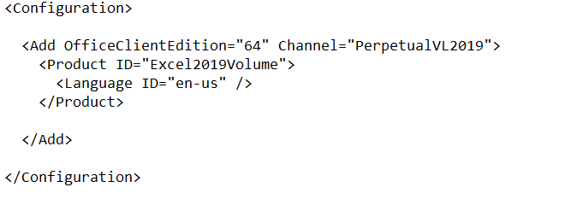

If we want to install the 2 apps i.e.; PowerPoint and Excel, we can append the code as shown below.

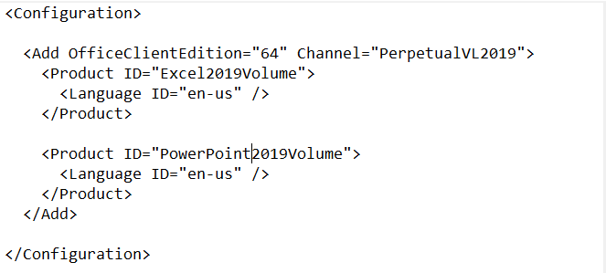

Now the configuration file is ready.

**How to download the setup file?**

Open command prompt, go to the path where the files has been extracted.

Type the below command:

Setup.exe /download /configuration-Office2019Enterprise.xml - Press enter

It will take some time to download the setup file and the estimated file size is **1.92GB.**

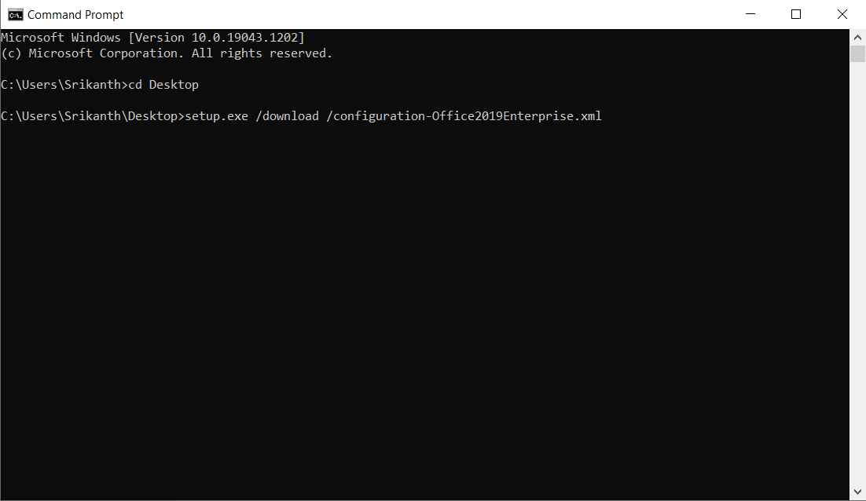

**How to install?**

Now let’s see how to install the applications.

Open the command prompt and type the below command and hit enter

Setup.exe /configure /configuration-Office2019Enterprise.xml - Press enter

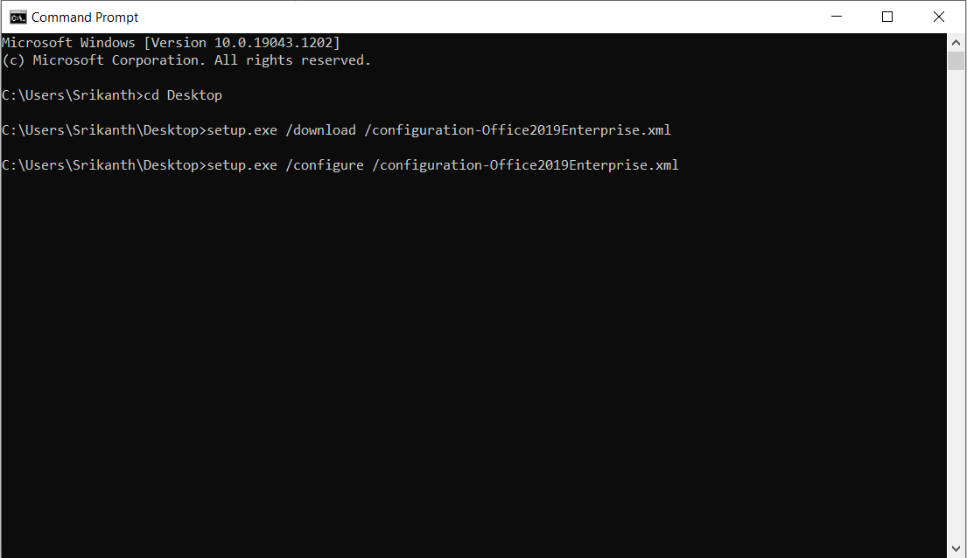

Now the installation process is starting